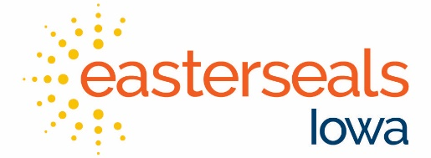

Process for making an appointment to donate Durable Medical Equipment to Easterseals Iowa:

- Easterseals Iowa accepts donations of usable durable medical equipment. We ask that you make sure that all equipment that is being donated is in usable, workable condition. If you are unsure if it is usable, an Assistive Technology team member can help to make this determination.
- If the equipment is in usable condition, please make an appointment to drop of equipment by calling 515-309-2395, our TTY number at 515-289-4069, or email us at atinfo@eastersealsia.org. If no one is available to take your call, please leave a message. A team member will be in contact with you within 24 hours.
- All donations should be dropped off at the Assistive Technology Center located at Easterseals Camp Sunnyside at 401 NE 66th Avenue, Des Moines, IA 50313. To find the AT Center, turn into the Easterseals Camp Sunnyside driveway and follow it up the hill. At the top of the hill, you will see the parking lot on your right. Keep driving straight and go back down the hill. At the bottom of the hill on the left-hand side there will be a sign for the Assistive Technology Center, two parking spaces, and a loading dock. Feel free to park in one of the parking spaces and come inside the Assistive Technology Center to let a team member know you are here.
- A team member will be able to assist you with filling out a donation form and unloading equipment if needed. All equipment should be dropped off on the loading dock.
- If there is equipment that could be damaged by rain, snow, etc., please leave it inside of the blue AT Center door.
- Within 3 weeks of making the donation, you will receive a letter from Easterseals acknowledging your donation.

FOR MORE INFORMATION
atinfo@eastersealsia.org (Email) • 1.866.866.8782 • 515.289.4069 (TTY)

