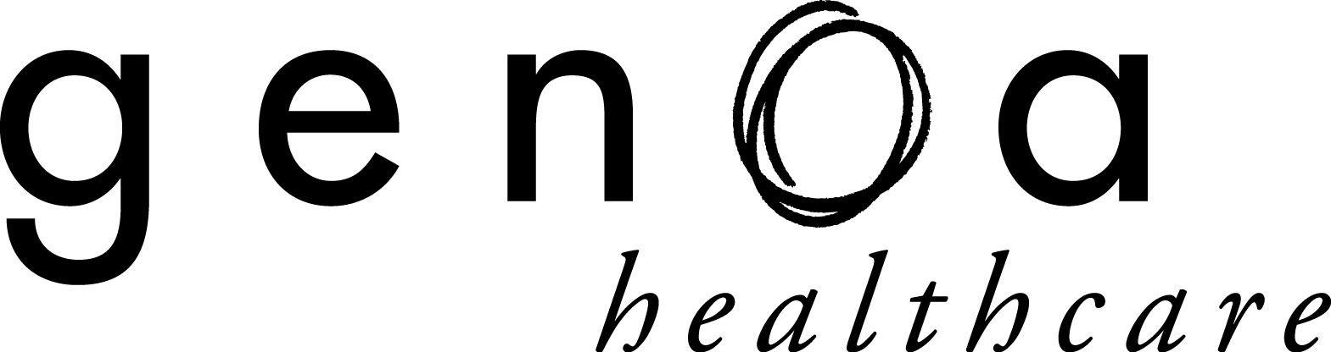

Dear Genoa Healthcare Client _________________________________:

State and Federal regulations require that we have a signed statement on file from you declining the use of child resistant containers for your prescription medications (this includes bubble packaging).

Please sign and date this statement and return it to Genoa Healthcare at your earliest convenience.

We appreciate your cooperation in this matter. If you have any questions or concerns, please do not hesitate to contact us.

Sincerely,

______________________________________
Genoa Healthcare Pharmacist

“I do not want my medications dispensed in child resistant containers.”

______________________________________ ____________
Signature Date

GENOA HEALTHCARE LLC
25 East Salem Street
Hackensack, NJ 07601
(201)546-5839

