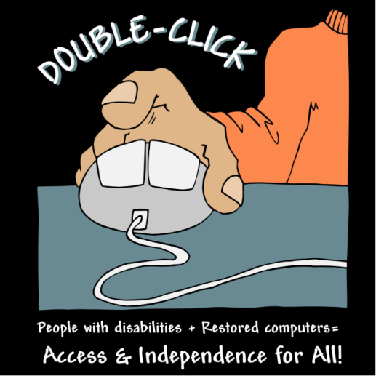

Overview of ‘Double-Click’ Project Loan Program

In order to help people with disabilities achieve individualized assistive technology, housing, financial literacy and other life goals, the ‘Double-Click’ Project provides a loan program. This program may provide financial assistance in the way of a loan limited to the acquisition of a refurbished computer.

Purpose of Program

The ‘Double-Click’ Project Loan Program is a program designed to promote knowledge and use of assistive technology among people with disabilities and their families. The purpose of the program is to serve as a resource for people with disabilities who have no other financial resource to attain a refurbished computer. The program is designed to provide temporary assistance within the guidelines adopted by the ‘Double-Click’ Project Loan Program. Because the program is a pilot program and is still being tested across the state, the long-term challenges of computer acquisition via loan are still unknown. Therefore the program will be revised as the ‘Double-Click’ Project learns more about the nature of loans for computers for people with disabilities.

How the Loan Program Operates

Application and Administration
The loan assistance includes screening and assessment of the household’s current financial situation, and assistance in understanding and applying for the loan. Participants who receive financial assistance may be required to participate in financial literacy counseling prior to receipt of funds. Funds are administered by the ‘Double-Click’ Project staff. Applications are accepted and reviewed at the Easter Seals offices located in Austin. Upon receiving an application for loan assistance, Double-Click staff will review the application for completeness, and determine whether or not the situation meets the criteria for the loan. If no further information is needed, an applicant will be notified within three weeks of the status of his or her application.

If, for any reason, an applicant is not satisfied with the assistance plan proposed by the Double-Click staff, the applicant may appeal the staff’s decision. An appeal or other complaint should be made in writing to the AT Project Specialist at the following address: 1611 Headway Circle, Building 2, Austin, Texas 78754. The appeal should include your name, address, telephone number, and describe the nature of the problem or complaint. A committee of representatives from the advisory committee, including representatives from the individual’s local area, will then be convened to decide whether or not the decision of the Double-Click staff should be modified. This committee will meet, make a decision, and notify the applicant of their decision in writing within 15 business days of the receipt of the appeal.

Procedure to Apply
In order to apply for assistance, applicant must have a documentable disability and be a Texas resident. Applicant must not have received a computer through the program within the last 2 years. Recipients must demonstrate financial need for the assistance. Examples of financial need include limited financial resources due to a hospitalization or illness, breaks in Medicaid coverage, an SSI or lower income, natural disasters, or a loss of employment. Recipients must also demonstrate that there is a reasonable expectation that their financial situation would not change significantly in the near future and there are some funds to support repayment of the loan.

The applicant may initiate the loan application request with any Double-Click staff. Staff will assist the applicant through the process as necessary.

Use of Funds
Funds are to be used solely for the purpose buying a refurbished computer from the ‘Double-Click’ Project. The monthly repayment plan for the loan will be determined on a case-by-case basis. Staff will work with the information provided by the applicant to develop an individual assistance plan that is appropriate to both the individual situation and the objectives of the program.

Participant Obligations
Prior to receipt of funds, participants must agree to work with staff on a mutually-agreed-upon loan repayment action plan. Recipients must also agree to participate in financial literacy sessions if prescribed by the ‘Double-Click’ Project staff. Loan assistance is provided in the form of a no-interest loan in order to continue the viability of the fund. Terms of repayment will vary dependent upon income level and the amount of the loan. The ‘Double-Click’ Project staff will explain the terms of repayment upon approval of the individual’s application.

Basic Eligibility Guidelines

In order to be eligible to receive assistance from this program, you or your family must . . .
- be in a distressed financial situation
- agree to participate in additional financial literacy counseling upon receipt of funds if necessary
- agree to repay any funds received as a loan
- not have received any loan assistance from the program in the last two years

