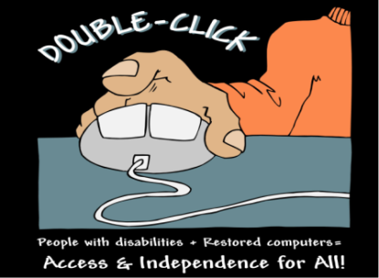 |  |  |  |  |  |  |  |  |  | Please return the application to:  Easter Seals Central Texas  c/o Double-Click Project  1611 Headway Circle, Building 2  Austin, Texas 78754  Phone: 512-615-6860  Fax: 512-615-7121  Email: dc@eastersealstx.org
COMPUTER ACQUISITION APPLICATION
The Double-Click Computer Acquisition Project provides eligible persons with disabilities living in Texas with a low-cost, desktop computer. Computer specifications include a minimum 1.60GHz – 2.6GHz Dual Core Processor, standard Dell tower case, DVD-RW Drive, 2GB – 4GB RAM, and a minimum 80GB Hard Drive. Each computer ships with Windows Vista Home Edition, preinstalled, speakers, monitor, keyboard, mouse and Libre Office preloaded for word processing, spreadsheet and database needs. The computers are shipped to each Double-Click recipient within Texas. The cost of the refurbished computer is $120 with a 17” LCD Monitor. Each computer comes with a 90 day warranty for hardware and a 30 day warranty for software.

In addition, the Double-Click Computer Acquisition Project provides a companion loan program to provide financial assistance for the acquisition of a refurbished computer through Double-Click. The loan program serves as a resource for people with disabilities that have no other financial resource to attain a refurbished computer.
Applicant Information (Please Enter Who the computer is for)
NAME:

DATE OF BIRTH: |  |  |  |  | PHONE: |  |  |  |  |  |  | EMAIL:
CURRENT ADDRESS: |  |  |  |  |  |  |  |  |  |  |  | COUNTY:
CITY: |  |  |  |  | STATE: |  |  |  |  |  |  | ZIP CODE:
GENDER | MALE |  | FEMALE |  | RACE: |  | AM. INDIAN,  ALASKAN NATIVE |  | ASIAN |  |  | BLACK |  | HISPANIC |  | WHITE | OTHER
NATURE OF DISABILITY (CHECK ALL THAT MAY APPLY, CIRCLE PRIMARY DISABILITY):
COGNITIVE |  |  |  | HEARING |  |  |  | MOBILITY |  |  |  |  | SPEECH |  |  | VISION
HOW WILL COMPUTER DESCRIBED ABOVE MEET YOUR INDIVIDUAL NEEDS?
COMMUNITY LIVING |  | EDUCATION |  |  |  | EMPLOYMENT |  |  |  | DATE APPLIED: |  |  |  |  | DATE RECEIVED (Office Use Only:
HOW WILL YOU BE PAYING FOR YOUR REFURBISHED COMPUTER?
PLEASE ENCLOSE CHECK OR MONEY ORDER TO :  EASTER SEALS CENTRAL TEXAS |  |  |  |  |  |  |  | $ |  |  | CHECK BOX IF YOU NEED TO APPLY FOR A DOUBLE-CLICK COMPUTER ACQUISITION LOAN

