Transition to a New Payroll Provider

We’re excited to announce that Paycor, Inc. is the new service provider of our payroll and human resources software.
Paycor provides integrated payroll, HR, applicant tracking, and time & attendance solutions to clients nationwide. They are dedicated to putting their clients first by delivering one-on-one personal service and easy-to-use products.
As of July 5th 2019, Paycor will be producing our paychecks and you will be able to use their website to view your check stub.

Your Next Steps
Register for access to Paycor! In order to access your online check stubs as well as the various Employee Self Service modules that are available to you, you will need to register for access to www.paycor.com .Below are instructions for completing this registration.

Prepare to register.
You'll need the following items to register.
- A web browser (find a full list here: www.paycor.com/system-requirements).
- You may need to add www.paycor.com to your trusted sites.
- Adobe Reader (you can download and install for free here: get.adobe.com/reader).

Start your registration.
Visit https://enterprise.paycor.com/Accounts/UserRegistration/Register to get started.

Tell us who you are.
You'll need to enter a few pieces of personal information, so we can verify your identify.
- Enter your last name and access code (your access code is your listed below)
  - Access One 113539
  - You may also need to enter your social security number and birth date.

Create your account.
If you have previously created other paycor.com accounts, you can merge this account’s access code by signing in when prompted, bypassing the steps below. Otherwise, create a new account by choosing a user name and password you'll be able to recall later.
- Enter a user name, email address and password that you'll use for signing in.

Complete your registration.
You will receive an email containing a verification code to the email address you entered.
- Enter the verification code when prompted to complete your registration.
- Select and answer a few security questions that can be used if you forget your user name or password.

Once you’ve registered, your Paycor.com home page will look something like the below image. Some of the options in the below image may not be available to you immediately, but they will be once each individual module of the system is launched.
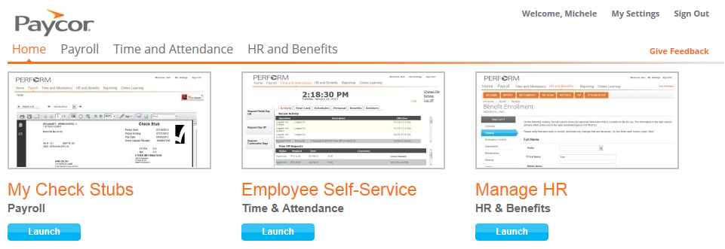
Note: | If you have any questions during this transition, please reach out to your supervisor or HR team.

