January 25, 2024

Dear Friend,
I’m writing to invite you to The Ability Affair, a very special fundraising event that Easterseals Central & Southeast Ohio will host on April 25, 2024, at The Fives Columbus.
The Ability Affair is our celebration of everything Easterseals is passionate about - supporting children, adults, and families in their lifelong journey to full inclusion and independence!
On April 25th, the spotlight will be on celebrating our Chance to Dance program and the individuals and families forever connected through this Easterseals program. Guests will experience our life-changing early intervention and adult programs in real-time, personally connect with Easterseals staff, and enjoy delicious food, signature cocktails, a live auction, and raffle drawings throughout the evening.
I hope you will join us for an evening of impact and inspiration that will raise critical funds to ensure that Easterseals continues to deliver exceptional programs and services so the children and adults of central and southeast Ohio living with all abilities can achieve limitless possibilities.
To purchase your tickets for The Ability Affair, or to sponsor tickets for Easterseals clients to attend, please scan the QR code below, or contact Sonja Emziah (semziah@easterseals-cseohio.org) with any questions or additional information you might require.
I look forward to celebrating all abilities and limitless possibilities with you on April 25th!
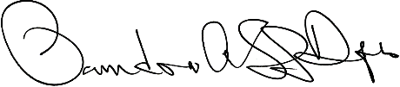
Sincerely,

Pandora Shaw-Dupras
CEO

Easterseals Central & Southeast Ohio is a 501(c)(3) organization supported by individual and community contributions.
Tax ID #31-437947

